**1. What is Strategic Management?**

* **Definition**: Strategic management is the process of planning, implementing, and evaluating strategies to achieve organizational goals and gain a **competitive advantage**.
* **Example**: A company like Apple uses strategic management to decide how to compete with Samsung and other tech giants.

**2. Key Terms:**

**a. Strategy:**

* **Definition**: A long-term plan to achieve goals by using resources effectively.
* **Example**: A company’s strategy might be to focus on innovation and premium pricing (like Apple).

**b. Business Model:**

* **Definition**: How a company creates, delivers, and captures value.
* **Example**: Amazon’s business model focuses on low prices, fast delivery, and a wide product range.

**3. Importance of Strategic Management**

* Helps organizations achieve **higher performance**.
* Encourages managers to **adapt to changes** in the business environment.
* Aligns all departments toward **common goals**.
* **Example**: Netflix’s strategic management helped it transition from DVD rentals to a global streaming giant.

**4. Components of Strategic Management**

**a. Vision:**

* **Definition**: A long-term goal that inspires the organization.
* **Example**: Tesla’s vision is “to accelerate the world’s transition to sustainable energy.”

**b. Mission Statement:**

* **Definition**: A statement that defines the organization’s purpose and goals.
* **Example**: Google’s mission is “to organize the world’s information and make it universally accessible and useful.”

**c. Goals and Objectives:**

* **Goals**: Broad, long-term outcomes (e.g., “Become the market leader in electric vehicles”).
* **Objectives**: Specific, measurable steps (e.g., “Sell 1 million electric cars by 2025”).

**5. Environmental Scanning**

* **Definition**: Analyzing internal and external factors that affect the organization.
* **Tools**:
  + **SWOT Analysis**: Shows **Strengths, Weaknesses, Opportunities, and Threats**.
    - **Example**: A company’s strength might be its strong brand, while a threat could be new competitors.
  + **PESTEL Analysis**: Examines **Political, Economic, Social, Technological, Environmental, and Legal** factors.
    - **Example**: A company might analyze how new government regulations (Legal) could impact its business.

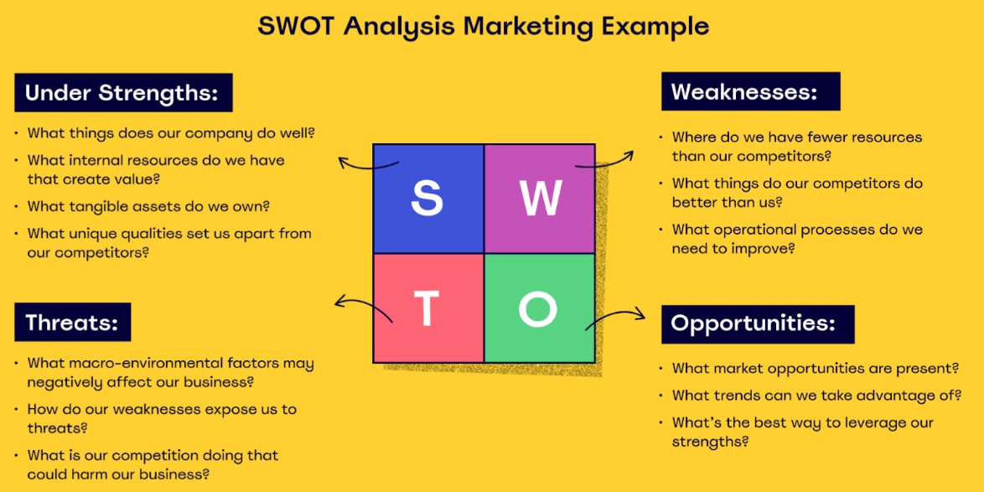

**SWOT Analysis of Jazz (Pakistan Mobile Communications Limited)**

Jazz is Pakistan’s largest mobile network operator, offering voice, data, and digital services.

**Strengths:**

* **Market Leader**: Jazz has the largest customer base in Pakistan.
* **Strong Infrastructure**: Jazz has a robust network with wide coverage across urban and rural areas.
* **Digital Services**: Jazz offers innovative digital services like JazzCash, a leading mobile wallet in Pakistan.

**Weaknesses:**

* **Customer Complaints**: Jazz faces criticism for network quality and customer service.
* **High Operating Costs**: Maintaining and upgrading network infrastructure is expensive.

**Opportunities:**

* **4G Expansion**: Jazz can expand its 4G services to rural areas where penetration is still low.
* **Digital Transformation**: Jazz can capitalize on the growing demand for digital services like mobile banking and e-commerce.

**Threats:**

* **Regulatory Challenges**: Strict regulations from the Pakistan Telecommunication Authority (PTA) can limit growth.
* **Competition**: Rival companies like Zong and Telenor are aggressively competing for market share.

**PESTEL**

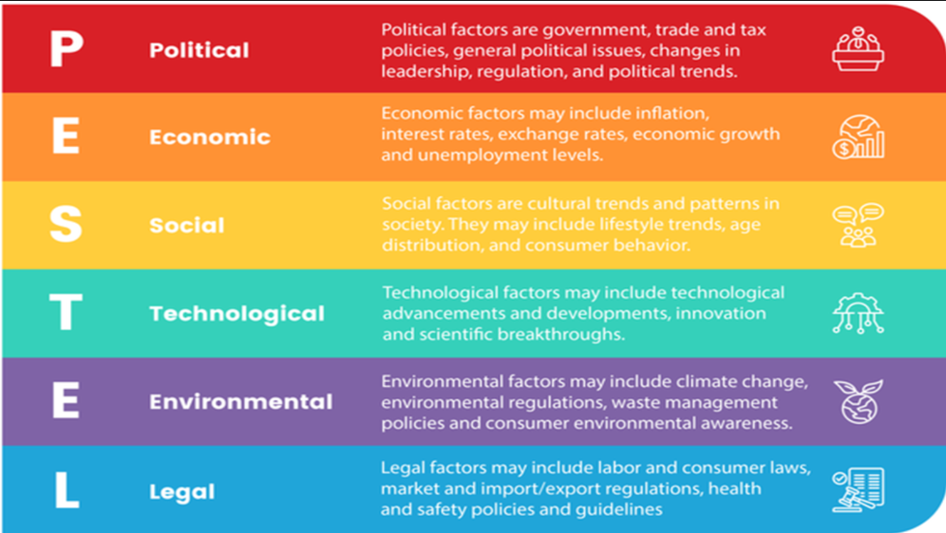

**PESTEL Analysis of Khaadi (Fashion Brand)**

Khaadi is a leading Pakistani fashion brand known for its traditional and modern clothing.

**Political:**

* **Trade Policies**: Changes in import/export policies can affect the cost of raw materials like fabric.
* **Government Support**: Government initiatives to promote local brands can benefit Khaadi.

**Economic:**

* **Consumer Spending**: Economic downturns can reduce consumer spending on fashion.
* **Inflation**: Rising prices of raw materials and labor can increase production costs.

**Social:**

* **Cultural Trends**: Khaadi can capitalize on the growing trend of wearing traditional Pakistani clothing.
* **Brand Loyalty**: Khaadi has a strong customer base that values its unique designs.

**Technological:**

* **E-commerce**: Expanding online sales platforms can help Khaadi reach more customers.
* **Automation**: Using technology in production can improve efficiency and reduce costs.

**Environmental:**

* **Sustainable Practices**: Khaadi can adopt eco-friendly practices, such as using organic fabrics, to attract environmentally conscious customers.
* **Waste Management**: Proper disposal of textile waste is essential to comply with environmental regulations.

**Legal:**

* **Labor Laws**: Khaadi must comply with labor laws regarding wages and working conditions.
* **Intellectual Property**: Protecting designs from being copied is crucial in the fashion industry.

**PESTEL Analysis of Lucky Cement**

Lucky Cement is one of Pakistan’s largest cement manufacturers.

**Political:**

* **Government Infrastructure Projects**: The government’s focus on infrastructure development (e.g., CPEC) boosts demand for cement.
* **Tax Policies**: Changes in tax policies can impact profitability.

**Economic:**

* **Inflation**: Rising inflation increases production costs.
* **Currency Devaluation**: A weaker Pakistani rupee makes importing raw materials more expensive.

**Social:**

* **Urbanization**: Increasing urbanization leads to higher demand for housing and construction.
* **Labor Issues**: Strikes or labor disputes can disrupt production.

**Technological:**

* **Automation**: Adopting advanced technologies can improve efficiency and reduce costs.
* **Energy Efficiency**: Investing in energy-efficient machinery can lower production costs.

**Environmental:**

* **Climate Change**: Extreme weather conditions can affect raw material availability.
* **Regulations**: Strict environmental laws may require costly upgrades to reduce emissions.

**Legal:**

* **Compliance**: Lucky Cement must comply with labor laws, safety regulations, and environmental standards.
* **Trade Policies**: Changes in import/export policies can affect the cement industry.

**6. Strategic Management Process**

**Step 1: Identify Mission and Goals**

* Define what the organization wants to achieve.
* **Example**: A bakery’s mission might be “to provide fresh, healthy baked goods to the community.”

**Step 2: Environmental Scanning**

* Analyze internal and external factors.
* **Example**: The bakery identifies a trend toward gluten-free products (Opportunity) but lacks the equipment to make them (Weakness).

**Step 3: Strategy Formulation**

* Develop strategies to achieve goals.
* **Example**: The bakery decides to introduce gluten-free products and invest in new equipment.

**Step 4: Strategy Implementation**

* Put the strategy into action.
* **Example**: The bakery trains staff, buys new equipment, and launches a marketing campaign for gluten-free products.

**Step 5: Strategy Evaluation**

* Monitor results and adjust.
* **Example**: The bakery tracks sales of gluten-free products and adjusts the menu based on customer feedback.

**7. Corporate Strategies:**

A corporate strategy is a comprehensive plan that outlines how a company will achieve its long-term goals and objectives.

**a. Growth Strategies:**

* **Concentration**: Focus on a specific market or product.
  + **Example**: Subway focuses on healthy sandwiches.
* **Vertical Integration**: Control the supply chain (e.g., backward or forward integration).
  + **Example**: A car manufacturer buys a tire company (backward integration).
* **Horizontal Integration**: Merge with or acquire competitors.
  + **Example**: Facebook acquiring Instagram.
* **Diversification**: Enter new markets or industries.
  + **Example**: Amazon expanding from e-commerce to cloud computing (AWS).

**b. Stability Strategy:**

* Maintain current operations.
* **Example**: A local bakery continues offering the same products without expanding.

**c. Renewal Strategies:**

**i) Retrenchment Strategy:** Shutdown unprofitable sectors or operations to stabilize profits and revenue.

**ii) Turn Around Strategy**: Redirection strategy, redesign strategy according to the problems

* **Example**: IBM shifted from hardware to software and services in the 1990s.

**8. Ansoff Matrix**:

The **Ansoff Matrix** is a strategic tool used by businesses to plan and analyze growth strategies. It helps companies decide how to grow by focusing on **products** and **markets**. The matrix has four quadrants, each representing a different growth strategy:

**1. Market Penetration**

* **Definition**: Selling existing products to existing markets.
* **Goal**: Increase market share by attracting more customers or encouraging existing customers to buy more.
* **Example**: A soft drink company offers discounts or promotions to increase sales of its existing products in its current market.

**2. Market Development**

* **Definition**: Selling existing products to new markets.
* **Goal**: Expand into new geographic areas or customer segments.
* **Example**: A Pakistani clothing brand like Khaadi starts selling its products in the Middle East or Europe.

**3. Product Development**

* **Definition**: Selling new products to existing markets.
* **Goal**: Introduce new products to meet the needs of current customers.
* **Example**: A smartphone company like Samsung launches a new model with advanced features for its existing customer base.

**4. Diversification**

* **Definition**: Selling new products to new markets.
* **Goal**: Enter entirely new markets with new products.
* **Example**: A company like Tesla, known for electric cars, starts producing solar panels for homes.

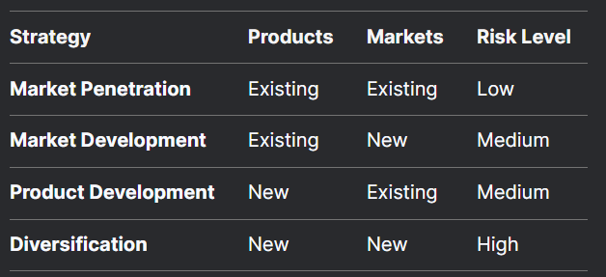

**Example of Ansoff Matrix in Action**

**Nestlé Pakistan**:

1. **Market Penetration**: Nestlé offers discounts on its existing products like Nescafé to increase sales in Pakistan.
2. **Market Development**: Nestlé introduces its products like Maggi noodles to new markets in Africa.
3. **Product Development**: Nestlé launches a new flavor of KitKat for its existing customers in Pakistan.
4. **Diversification**: Nestlé enters the health supplement market with new products like protein shakes.

**9. Tools for Strategic Analysis**

**a. BCG Matrix:**

* **Definition**: A tool to analyze a company’s product portfolio based on **market share** and **market growth**.
* **Quadrants**:
  + **Stars**: High growth, high market share (e.g., Apple’s iPhone).
  + **Cash Cows**: Low growth, high market share (e.g., Coca-Cola).
  + **Question Marks**: High growth, low market share (e.g., a new product).
  + **Dogs**: Low growth, low market share (e.g., outdated products).
* **Example**: A company might invest in Stars and phase out Dogs.

**b. Porter’s Five Forces:**

* **Definition**: A framework to analyze industry competition.
* **Forces**:
  1. **Threat of New Entrants**: How easy is it for new competitors to enter the market?
  2. **Bargaining Power of Suppliers**: How much control do suppliers have over prices?
  3. **Bargaining Power of Buyers**: How much control do customers have over prices?
  4. **Threat of Substitutes**: Are there alternative products or services?
  5. **Industry Rivalry**: How intense is the competition?
* **Example**: In the smartphone industry, rivalry is high (e.g., Apple vs. Samsung), and the threat of substitutes is low.

**10. Competitive Strategies**

**a. Cost Leadership:**

* Offer the lowest prices in the industry.
* **Example**: Walmart’s low-cost strategy.

**b. Differentiation:**

* Offer unique products or services.
* **Example**: Apple’s premium products and ecosystem.

**c. Focus/Niche Strategy:**

* Target a specific market segment.
* **Example**: Ferrari focuses on luxury sports cars.

**11. Role of Competitive Advantage**

* **Definition**: A unique edge that allows a company to outperform competitors.
* **Types**:
  + **Quality**: Offering superior products (e.g., Rolex watches).
  + **Innovation**: Introducing new technologies (e.g., Tesla’s electric cars).
  + **Customer Service**: Providing exceptional support (e.g., Amazon’s customer service).